# PROJECT DOCUMENTATION

# Fitflex: Your Personal Fitness Companion

# 1. Introduction

• **Project Title:** Fitflex: Your Personal Fitness Companion

• **Team ID:** [Your Team ID]

• **Team Leader:**

**Name:** Priyadharshini V S**,**

**Email ID**: priyadharshini.v.s.24ds039@gmail.com

• **Team Members:**

**Name**: Baby Shalini O, **Email ID**: baby.shalini.024ds003@gmail.com

**Name:** Chinmayi R, **Email ID:** chinmayi.r.24ds008@gmail.com

**Name:** Harini A, **Email ID:** harini.a.24ds015@gmail.com

**Name:** Lavanya S, **Email ID**: lavanya.s.24ds025@gmail.com

# 2. Project Overview

• **Purpose:** The Exercise App helps users stay fit by providing workout challenges, a run tracker, and tools to monitor calories, distance, and pace. It also allows users to explore diet plans and track their fitness progress.

**• Features:**

- Exercise challenges (push-ups, squats, etc.)

- Run tracker with timer, distance, pace, and calories

- Daily workout suggestions

- Searchable exercise library with instructions and images

- User-friendly interface with Home, About, and Exercise Detail pages

# 3. Architecture

• **Frontend:** React.js, JavaScript, CSS

• **Backend:** Node.js & Express.js

• **Database:** No database is used currently.

# 4. Setup Instructions

• **Prerequisites:** Node.js, Git, React.js, Visual Studio Code

• Installation Steps:

# Clone the repository

git clone <repository-url>

# Install client dependencies

cd client

npm install

# Install server dependencies

cd../server

npm install

# 5. Folder Structure

exercise-app/

│-- node_modules/

│

│-- public/

│ │-- images/

│-- src/

│ │-- components/

│ │-- data/

│ │-- pages/

│ │-- styles/

│ │-- App.css

│ │-- App.jsx

│ │-- index.css

│ │-- index.jsx

# 6. Running the Application

• **Start the frontend:** cd exercise-app  
 npm start

• **Access:** Visit http://localhost:3000

**7. API Documentation**

Currently, the Exercise App does not use any external API or backend service.  
All features (time tracker, run tracker, exercises, challenges) are handled in the **frontend** using React state and logic.

# 8. Authentication

# Current State: No authentication system is implemented in the current version. All users can access the app freely.

# 9. User Interface

* Home Page
* About Page
* Exercises Page
* Run Tracker Page
* Daily Challenges Page

# 10. Testing

• Manual testing of features and navigation

• Tools: Chrome Dev Tools

# 11. Screenshots or Demo

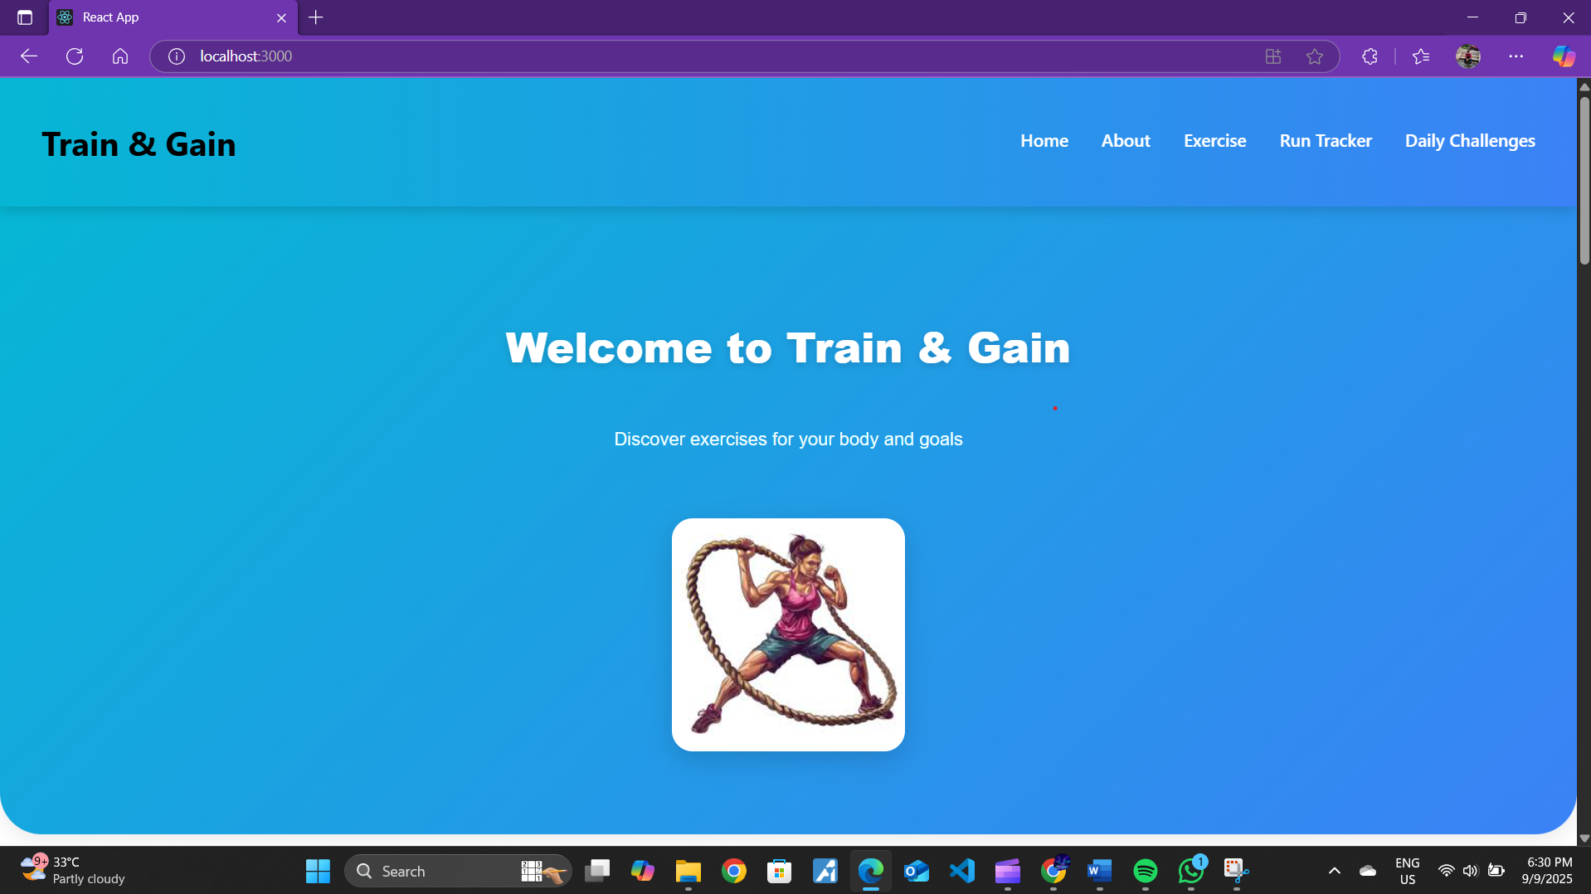

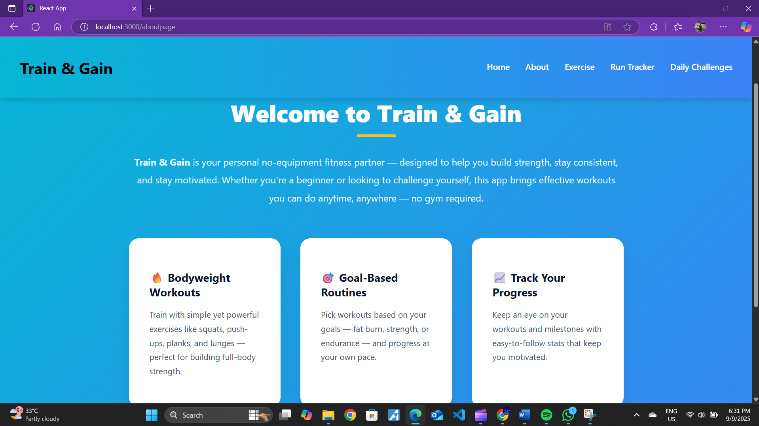

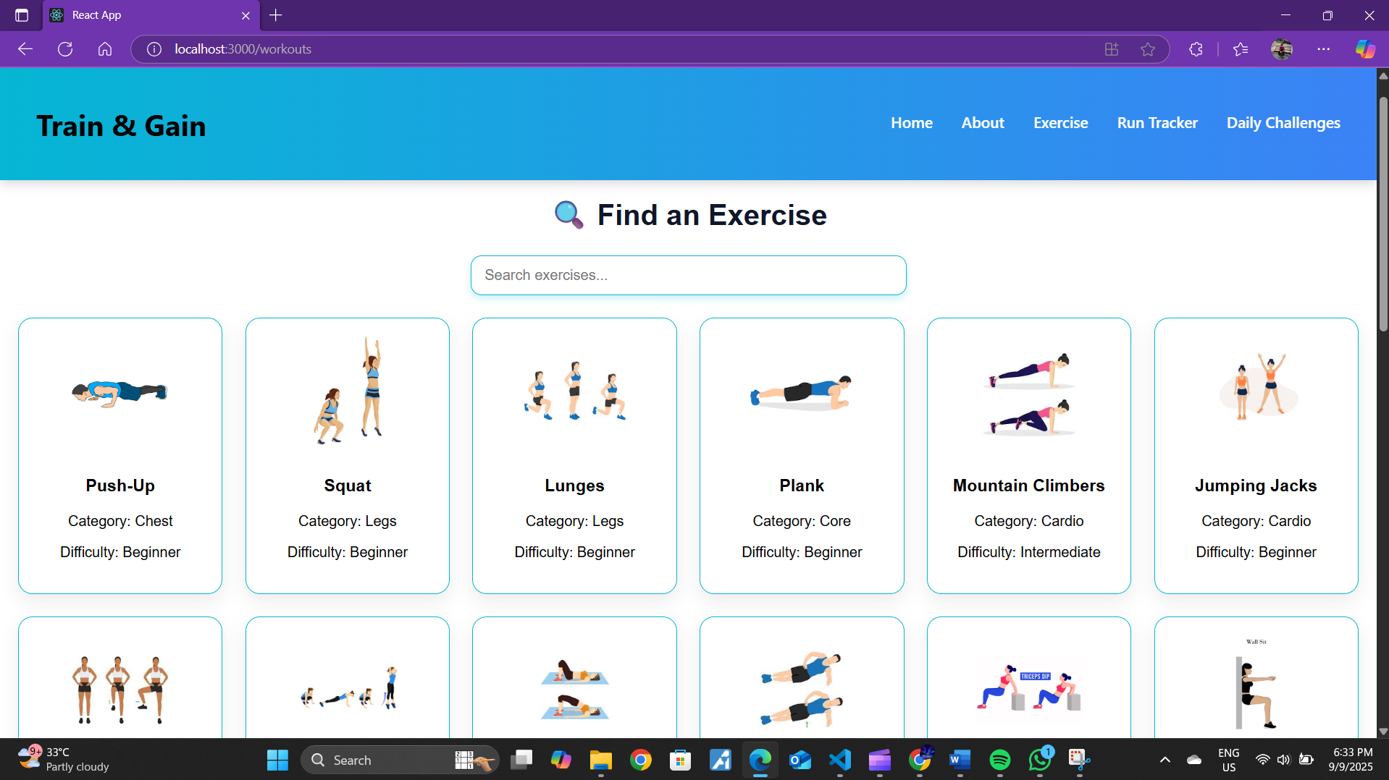

**Demo Link:** https://drive.google.com/file/d/1C74kxIBcuogrnQW-QbnOK3GOqXi8jniR/view?usp=drive_link

# 12. Known Issues

• GPS tracking not implemented

• No backend integration for persistent data storage

# 13. Future Enhancements

• Add Pilates, Yoga, and advanced workout categories

• Implement GPS-based tracking for runs

• Add user authentication and progress history

• Mobile app version